# Instructions to All Participants

# ICADL 2021

## General

* You should keep connected using Zoom during the session, which is the main platform for ICADL 2021.
* To ensure the security of conference sessions, passwords for Zoom meetings and Webinar will be sent to you ONE DAY before the conference.
* You can access all conference sessions through the links posted on the conference program section at ICADL2021 page: <https://icadl.net/icadl2021/index.html#Program>
* If you need any support, please contact us at: [icadl2021-chairs@ml.cc.tsukuba.ac.jp](mailto:icadl2021-chairs@ml.cc.tsukuba.ac.jp)
* “5-MINUTE RULE”: if you encounter any unexpected technical issues, log back into the same zoom room in 5 MINUTES. We will not make any additional announcements.

## Downloading Zoom

* Please download Zoom from [www.zoom.us/download#client_4meeting](http://www.zoom.us/download#client_4meeting)
* More Zoom training videos: <https://support.zoom.us/hc/en-us/articles/206618765-Zoom-video-tutorials>
* Zoom privacy and security information: <https://zoom.us/docs/en-us/privacy-and-security.html>

## Joining a meeting

ICADL 2021 provides virtual conference rooms: the links are available on the Program Section in ICADL2020 website: <https://icadl.net/icadl2021/index.html#Program>

You can simply click the link of a room, followed by redirecting to a Zoom Meeting.

You can also join a meeting by inputting the Meeting ID and Password, as shown in Figs. 1-4. Please use your real name for the meeting.

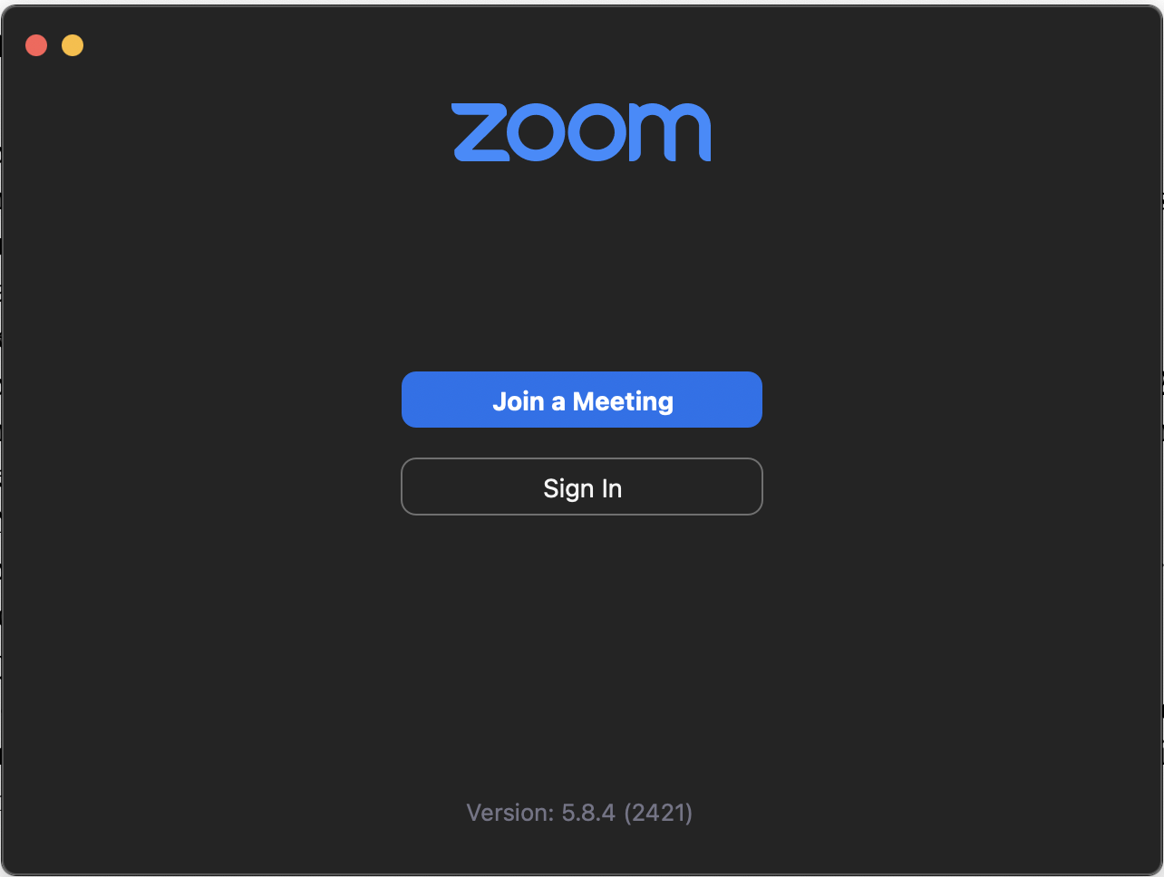

Fig.1 Zoom page for joining a meeting

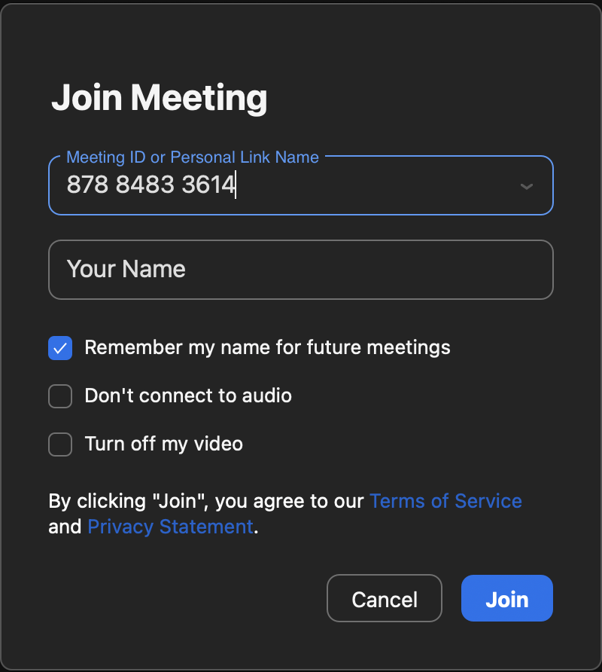

Fig.2 Join a meeting with Meeting ID

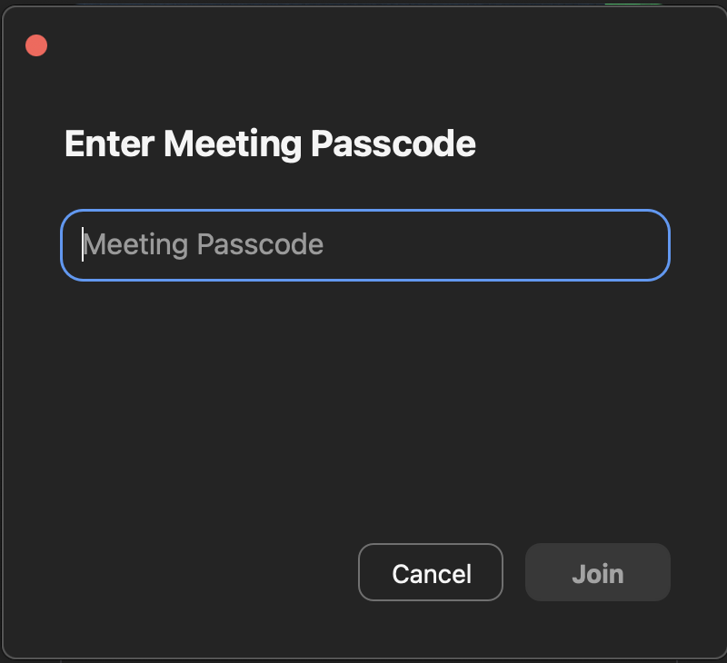

Fig.3 Enter meeting passcode

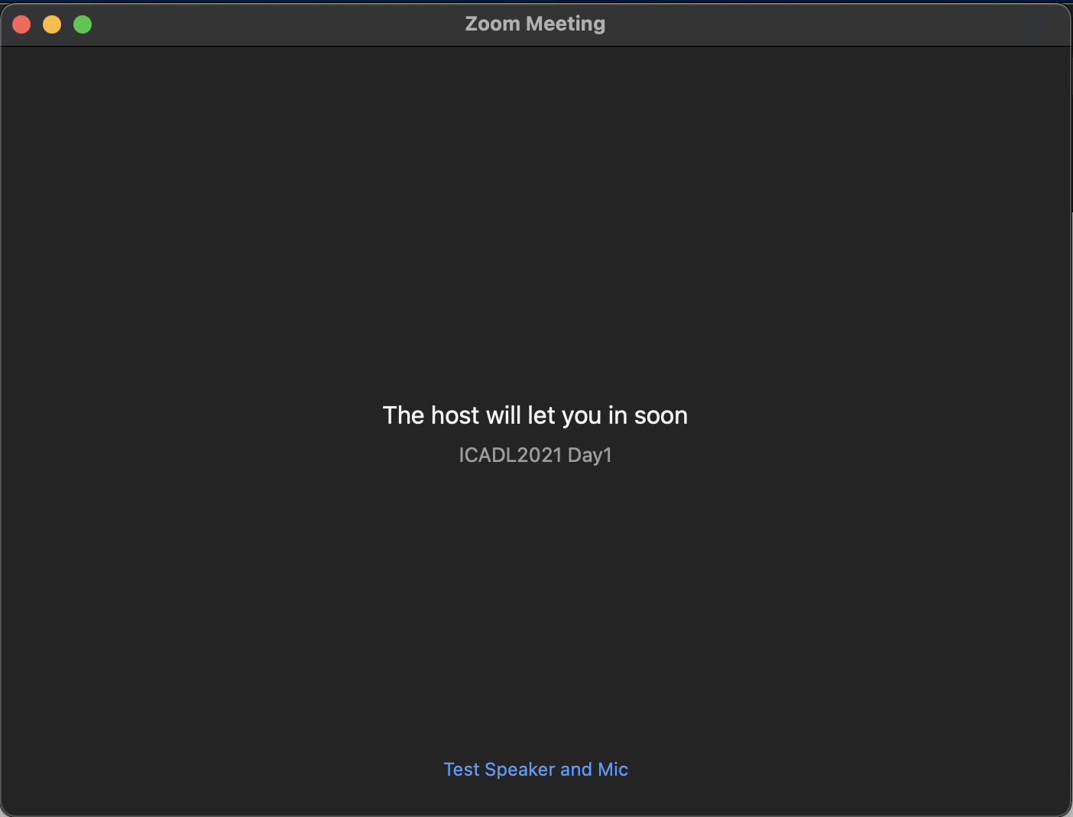

Fig.4 The waiting room page before being admitted to the meeting

## Audio and Video

After joining in the meeting, you will be asked to choose one of the audio options (see Fig.5). Generally, you can choose “Join with Computer Audio”.

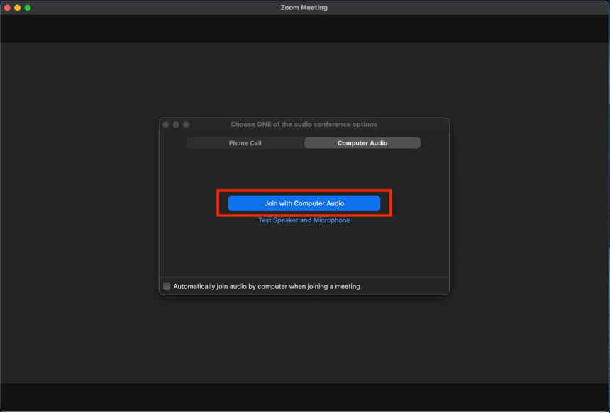

Fig.5 Audio and Video setting

## Overview of the zoom

After selecting the audio option, your screen will look like Fig.6. In this figure, there will be several control buttons at the bottom of your screen.

* Unmute: unmute yourself.
* Start Video: turn on your camera and start a video meeting.
* Participants: demonstrate the list of participants.
* Chat: Open the chat window.
* Share Screen: share your screen if you are going to share your slides or video. It is up to the session chair whether you can share the screen or not.
* Leave: leave the meeting.

­­­­­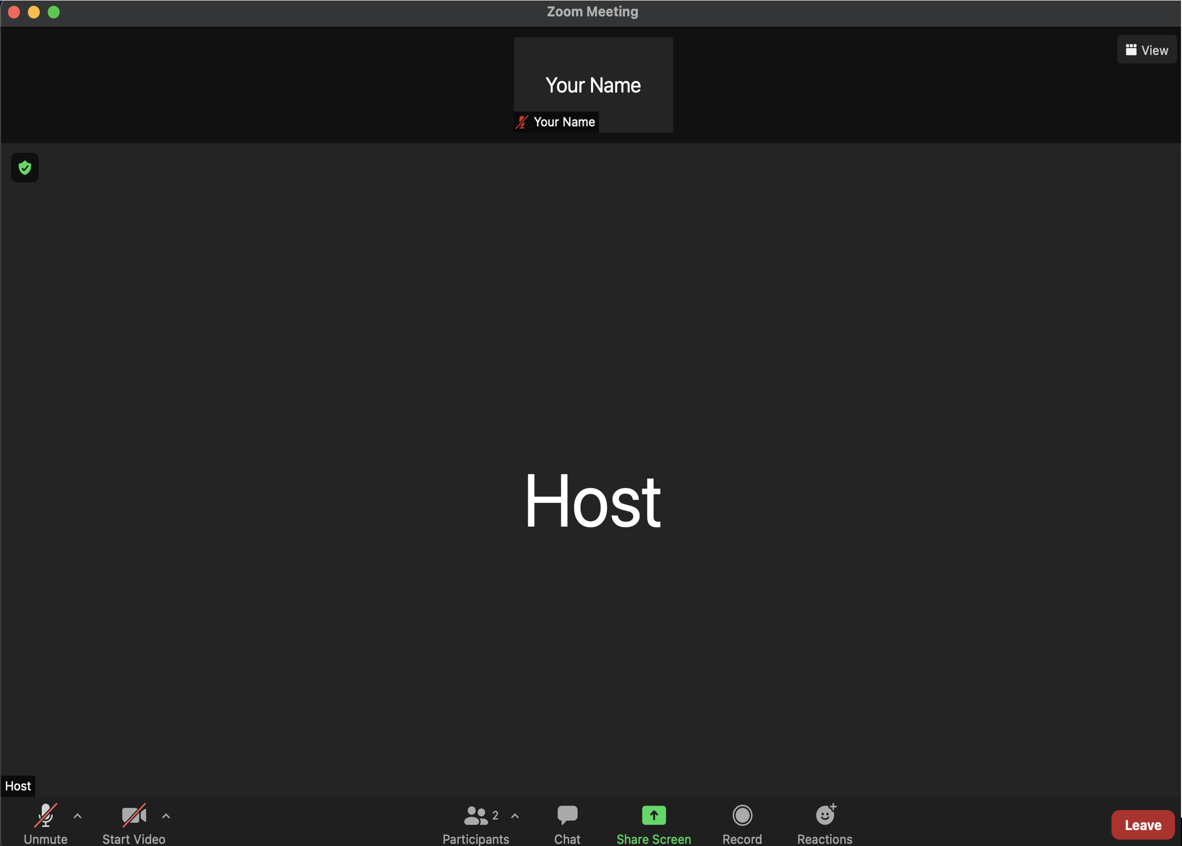

Fig.6 Zoom Control Panel

## Unmute yourself

By default, all participants will be muted during the meeting. In the Q&A session, you can click “Unmute” or “Unmute Me” to unmute yourself. If failed, you can click “Raise Hand” to ask the session chair to unmute you (Fig.7).

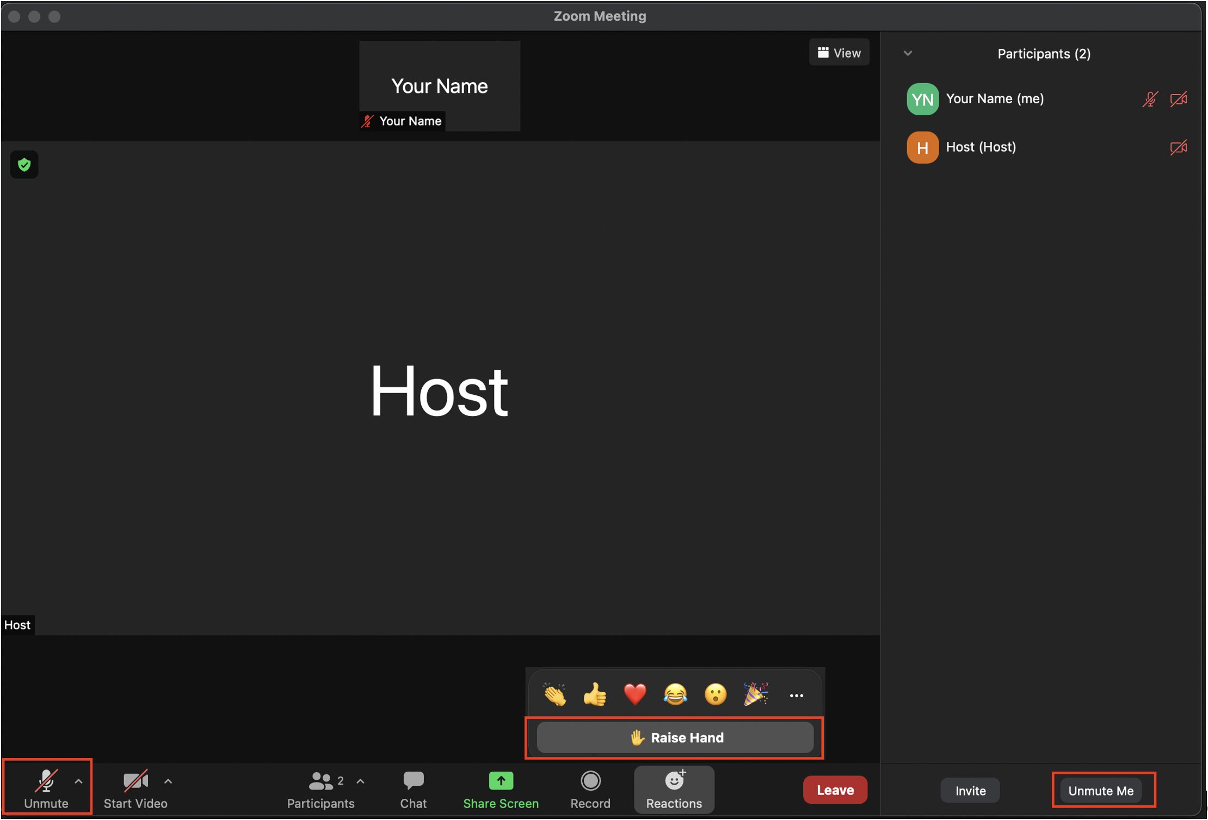

Fig.7 You can raise your hand by clicking “Raise Hand” button

## Change your name

In the participants’ list, put the cursor on your name, there will be a “More” option. By clicking “More”, you can find the “Rename” option to change your name (Fig.8). Please keep using your real name in the meeting.

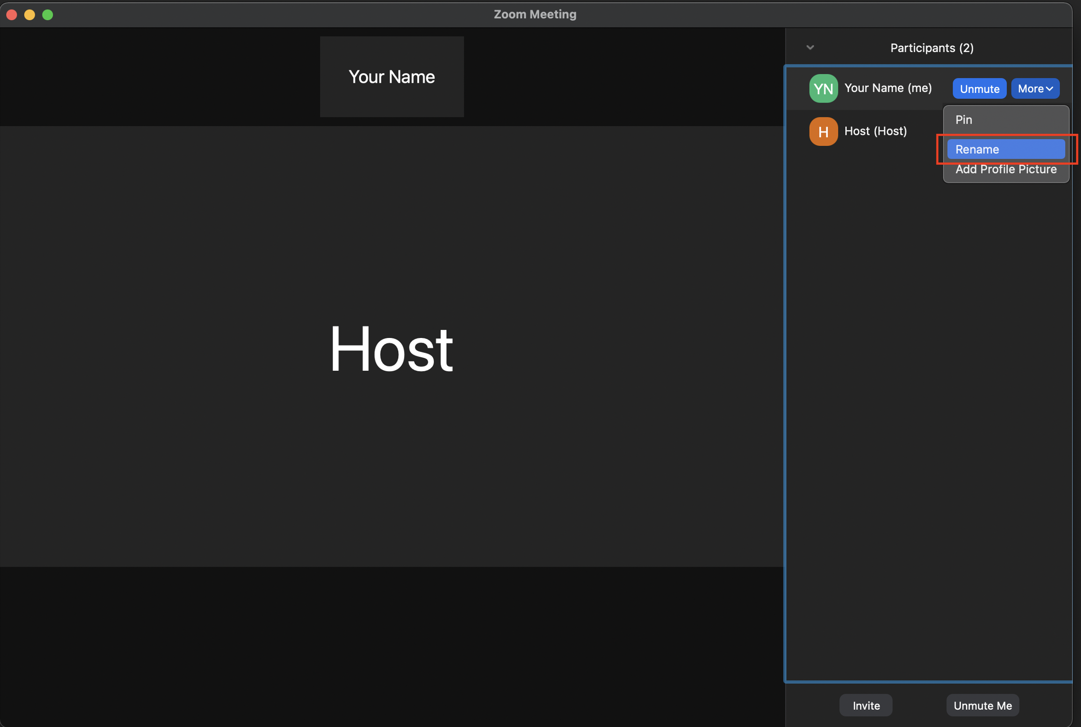

Fig.8 Rename your screen name

## Chat

By clicking “Chat” in the main window, you can start group chat (see Fig.9).

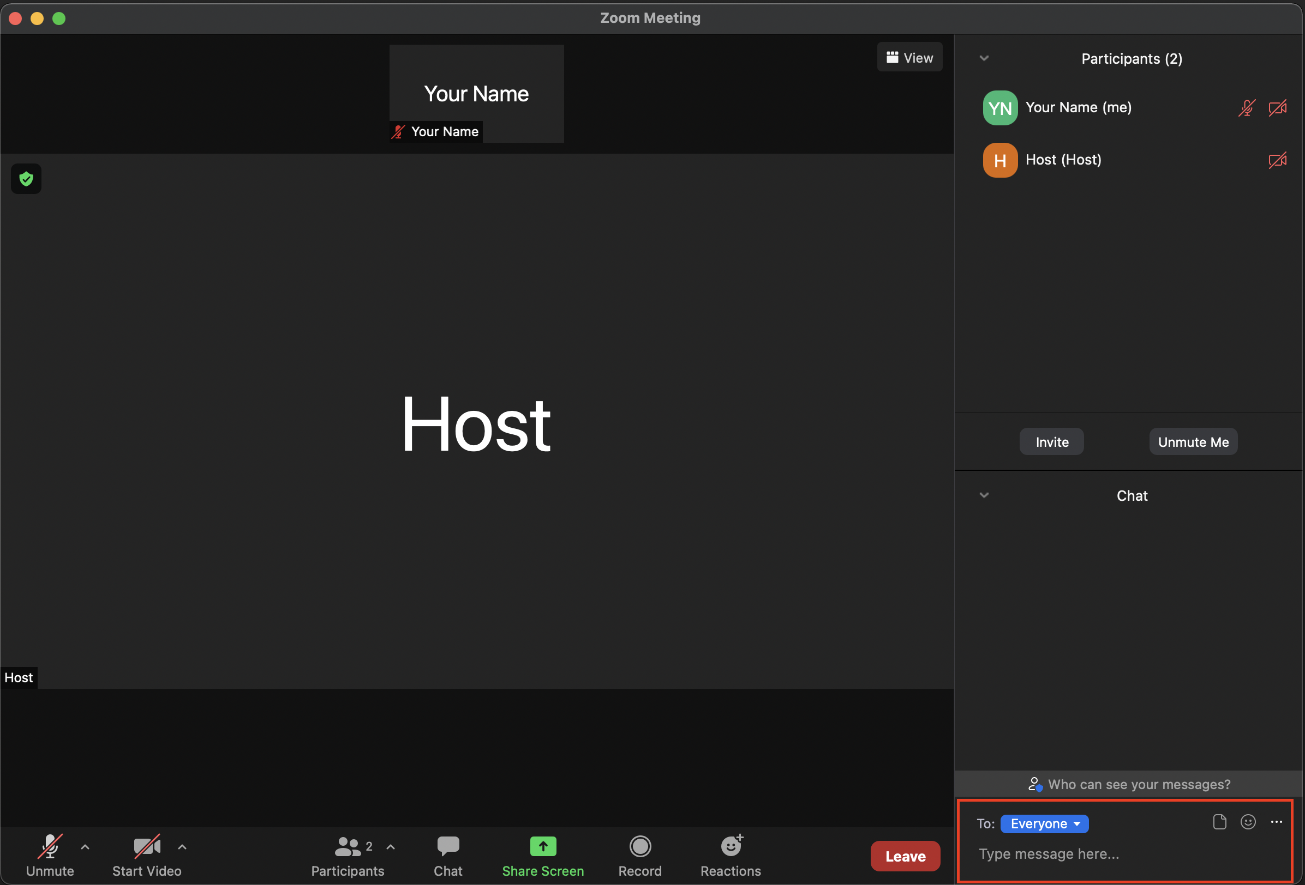

Fig.9 Chat publically to everyone or privately only with the chair